Need Assessment

Meissa Bayo

Contents

Needs Assessment 3

Read Me (How to operate) 5

# Needs Assessment

**AJAX/JSON Lab**

Description:

in this project, I was asked about creating a photo gallery using AJAX. I want to make sure that I read, parse, and refresh the server data. I want to be the only one to access the images. Because of this, it is going to be both local to my computer and authenticated. All photos will be provided as well as a very specific username and password that I do not want to be changed.

Requirements:

1. You must read server data
2. You must parse server data
   1. Breaking apart title and image
3. You must refresh server data
4. You must have at least ten images
5. You must allow for user interaction with your gallery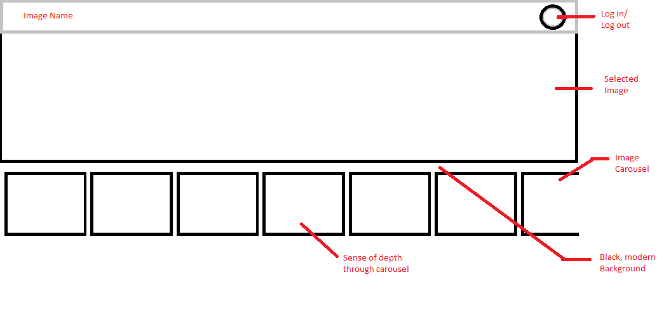

* 1. Carousel through images

1. User interactions must be secure and authenticated
   1. Must have sign in and sign out
2. AJAX setup
   1. Request
   2. Response
      1. XML
         1. <images>

<image>

</image>

<title>

</title>

</images>

# Read Me (How to operate)

Here is my photo gallery with all the photos that I provided.

Start by typing localhost:8080 /8403/ AJAX-Image-Gallery into your browser’s url

Then, log in.

Username and Password as mandated:

User:

Meissa

Password:

Password

*To add photos just download them to C:\wamp64\www\8403\ AJAX-Image-Gallery\images

Then make sure to hit the Reset button at the bottom right hand side of you screen and your image will appear.